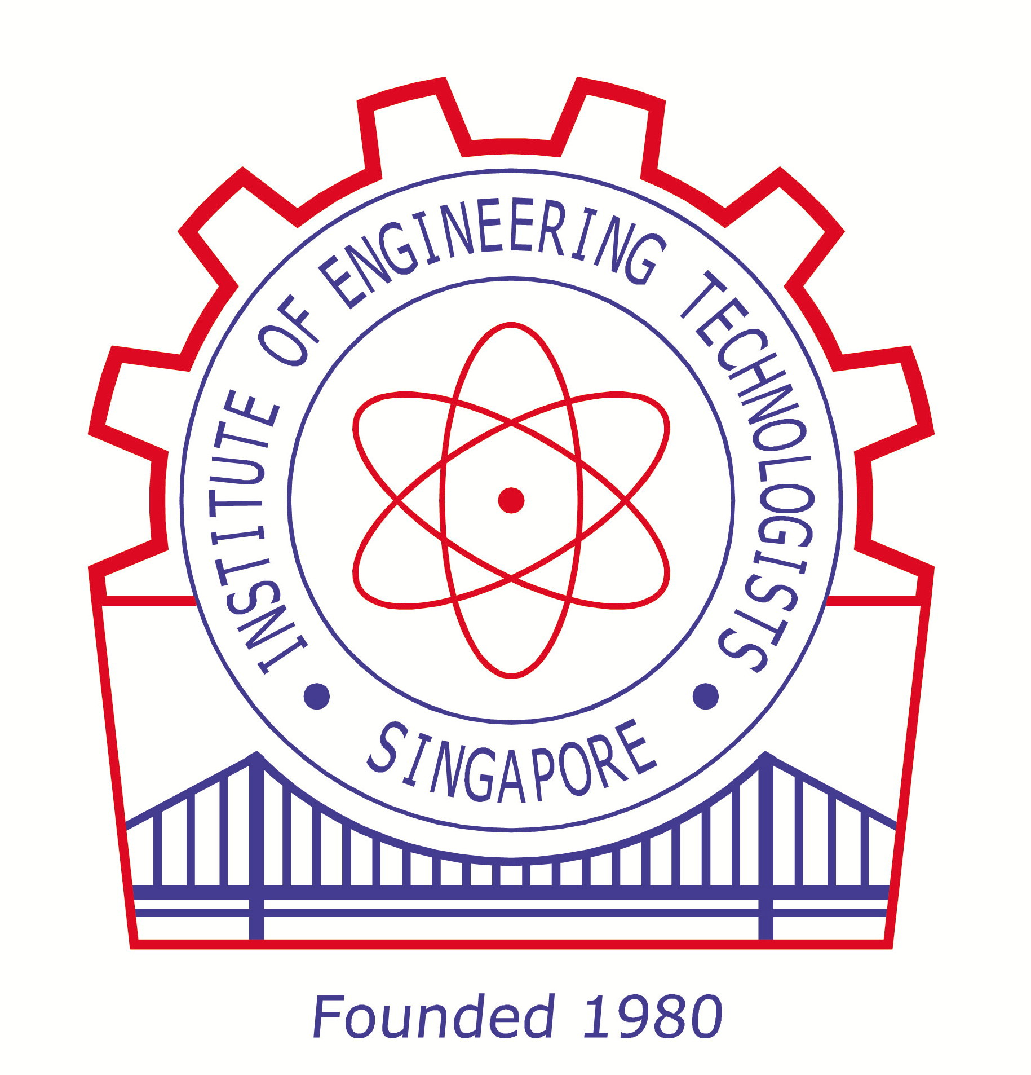 | Jointly organized by  The Engineers Australia –Singapore Group  and  Singapore Institute of Engineering Technologists (SIET) |   [Singapore Group]
Lunar New Year Gathering
cum Professional Talk on
‘Get Chartered via Engineers Australia’
Date | Saturday, 23 February 2013
Time | 3.00pm – 5.00pm
Venue | Nanyang @ THE CENTRAL  (Level 4: #04-01)  [Above Clarke Quay MRT Station]  Tel: 6777 6996 (Nanyang)
Speakers/  Highlights | 3.00pm – 3.30pm:  Introduction to SIET :  (Dr Sam MK, Honorary Secretary, SIET)  . Its Formation;  . Membership Structure;  . Benefits of SIET Membership;  . Pathways : Technicians ➔ Technologists ➔ Engineers.  . SIET’s Global Networks.  3.30pm – 4.30pm:  Speaker : Er Lee Keh Sai from Engineers Australia-Singapore Group  Get Chartered via Engineers Australia :  - About Engineers Australia (EA)  - The Engineering Team  - The Competency Standards  - About EA Membership  - National Engineering Registers  - Preparing an Application for Assessment of Eligibility for Membership (Stage 1 Competency)  - Becoming Chartered  - What is eChartered?  4.30pm – 5.00pm:  Questions & Answers
For Registration | For SIET Members:  Mr Loo YS, HP : 9662 9459 ; Email: sietsg@gmail.com  Dr Sam MK, HP : 9674 0515; Email: sammk1951@gmail.com  For EA Members:  Mr Lawrence, HP : 96167862; Email: chungmin@singnet.com.sg
[Established in 1919] | Engineers Australia  [website: www.engineersaustralia.org.au ]  The Institution of Engineers Australia, often shortened to IEAust and trading as Engineers Australia, is a professional body and not-for-profit organisation dedicated to being the national forum for the advancement of the engineering field within Australia. It has over 85,000 members from all engineering disciplines.  Membership  - Professional Engineer (MIEAust) – completion of an Engineers Australia-accredited four or more years engineering qualification in Australia, or equivalent, and minimum of three years acceptable work experience at the level of Professional Engineer  - Engineering Technologist (TMIEAust) – completion of an Engineers Australia-accredited three-year engineering technology qualification in Australia, or equivalent, and minimum of three years acceptable work experience at the level of Engineering Technologist  - Engineering Associate (AMIEAust) – completion of an Engineers Australia recognised two-year engineering associate qualification in Australia, or equivalent, and minimum of three years acceptable work experience at the level of Engineering Officer.  National Engineering Registers  Registration on the National Engineering Registers is available in three occupational categories:  - National Professional Engineers Register (NPER)  - National Engineering Technologists Register (NETR)  - National Engineering Associates Register (NEAR)
新 加 坡 工 程 专 家 协 会
Singapore Institute of Engineering Technologists (SIET)
Website : www.siet.org.sg
. SIET is a professional body for Engineering Technologists & Technicians in Singapore with Global Networks.
. SIET is a Founder Member of the World Federation of Engineering Organizations (WFTO).[Website: www.wfto.org ]
. SIET is a Full Member of the Singapore Professional Centre (SPC). [Website : www.spc.org.sg ]
Supported by

[A Professional Partner of SIET]
6 Eu Tong Sen Street #04-01 THE CENTRAL,
Singapore 059817.
Tel: (65) 6777 6996
Website : www.nanyang.edu.sg
ENGINEERING :
The Career Field That Improves Our Quality of Life

“Engineer” conceives it;
“Technologist” implements it;
“Technician” operates it.
Speaker’s Profile.

Er. Lee Keh Sai
Email: leekehsai@gmail.com

Er. Lee graduated from Faraday House Engineering College in London in Electrical Power Engineering in 1963. Thereafter he worked as a Deputy Head of Electrical Department in Shell Refinery for 3 years. In 1970, he was the founder and principal of K.S Lee & Associates. He has more than 40 years of industrial experience in electrical power and energy systems, design optimization and methods to conserve energy and power quality solutions. He is a Registered Professional Electrical Engineer (PEng), a Chartered Engineer (UK), Chairman of the Professional Interview Panel in the Professional Engineers Board, Singapore and an accredited Arbitrator in the Institution of Engineers, Singapore. Er. Lee has been working as a Principal Technical Consultant at Schneider Electric S.E. Asia (HQ) Pte Ltd since 2008.

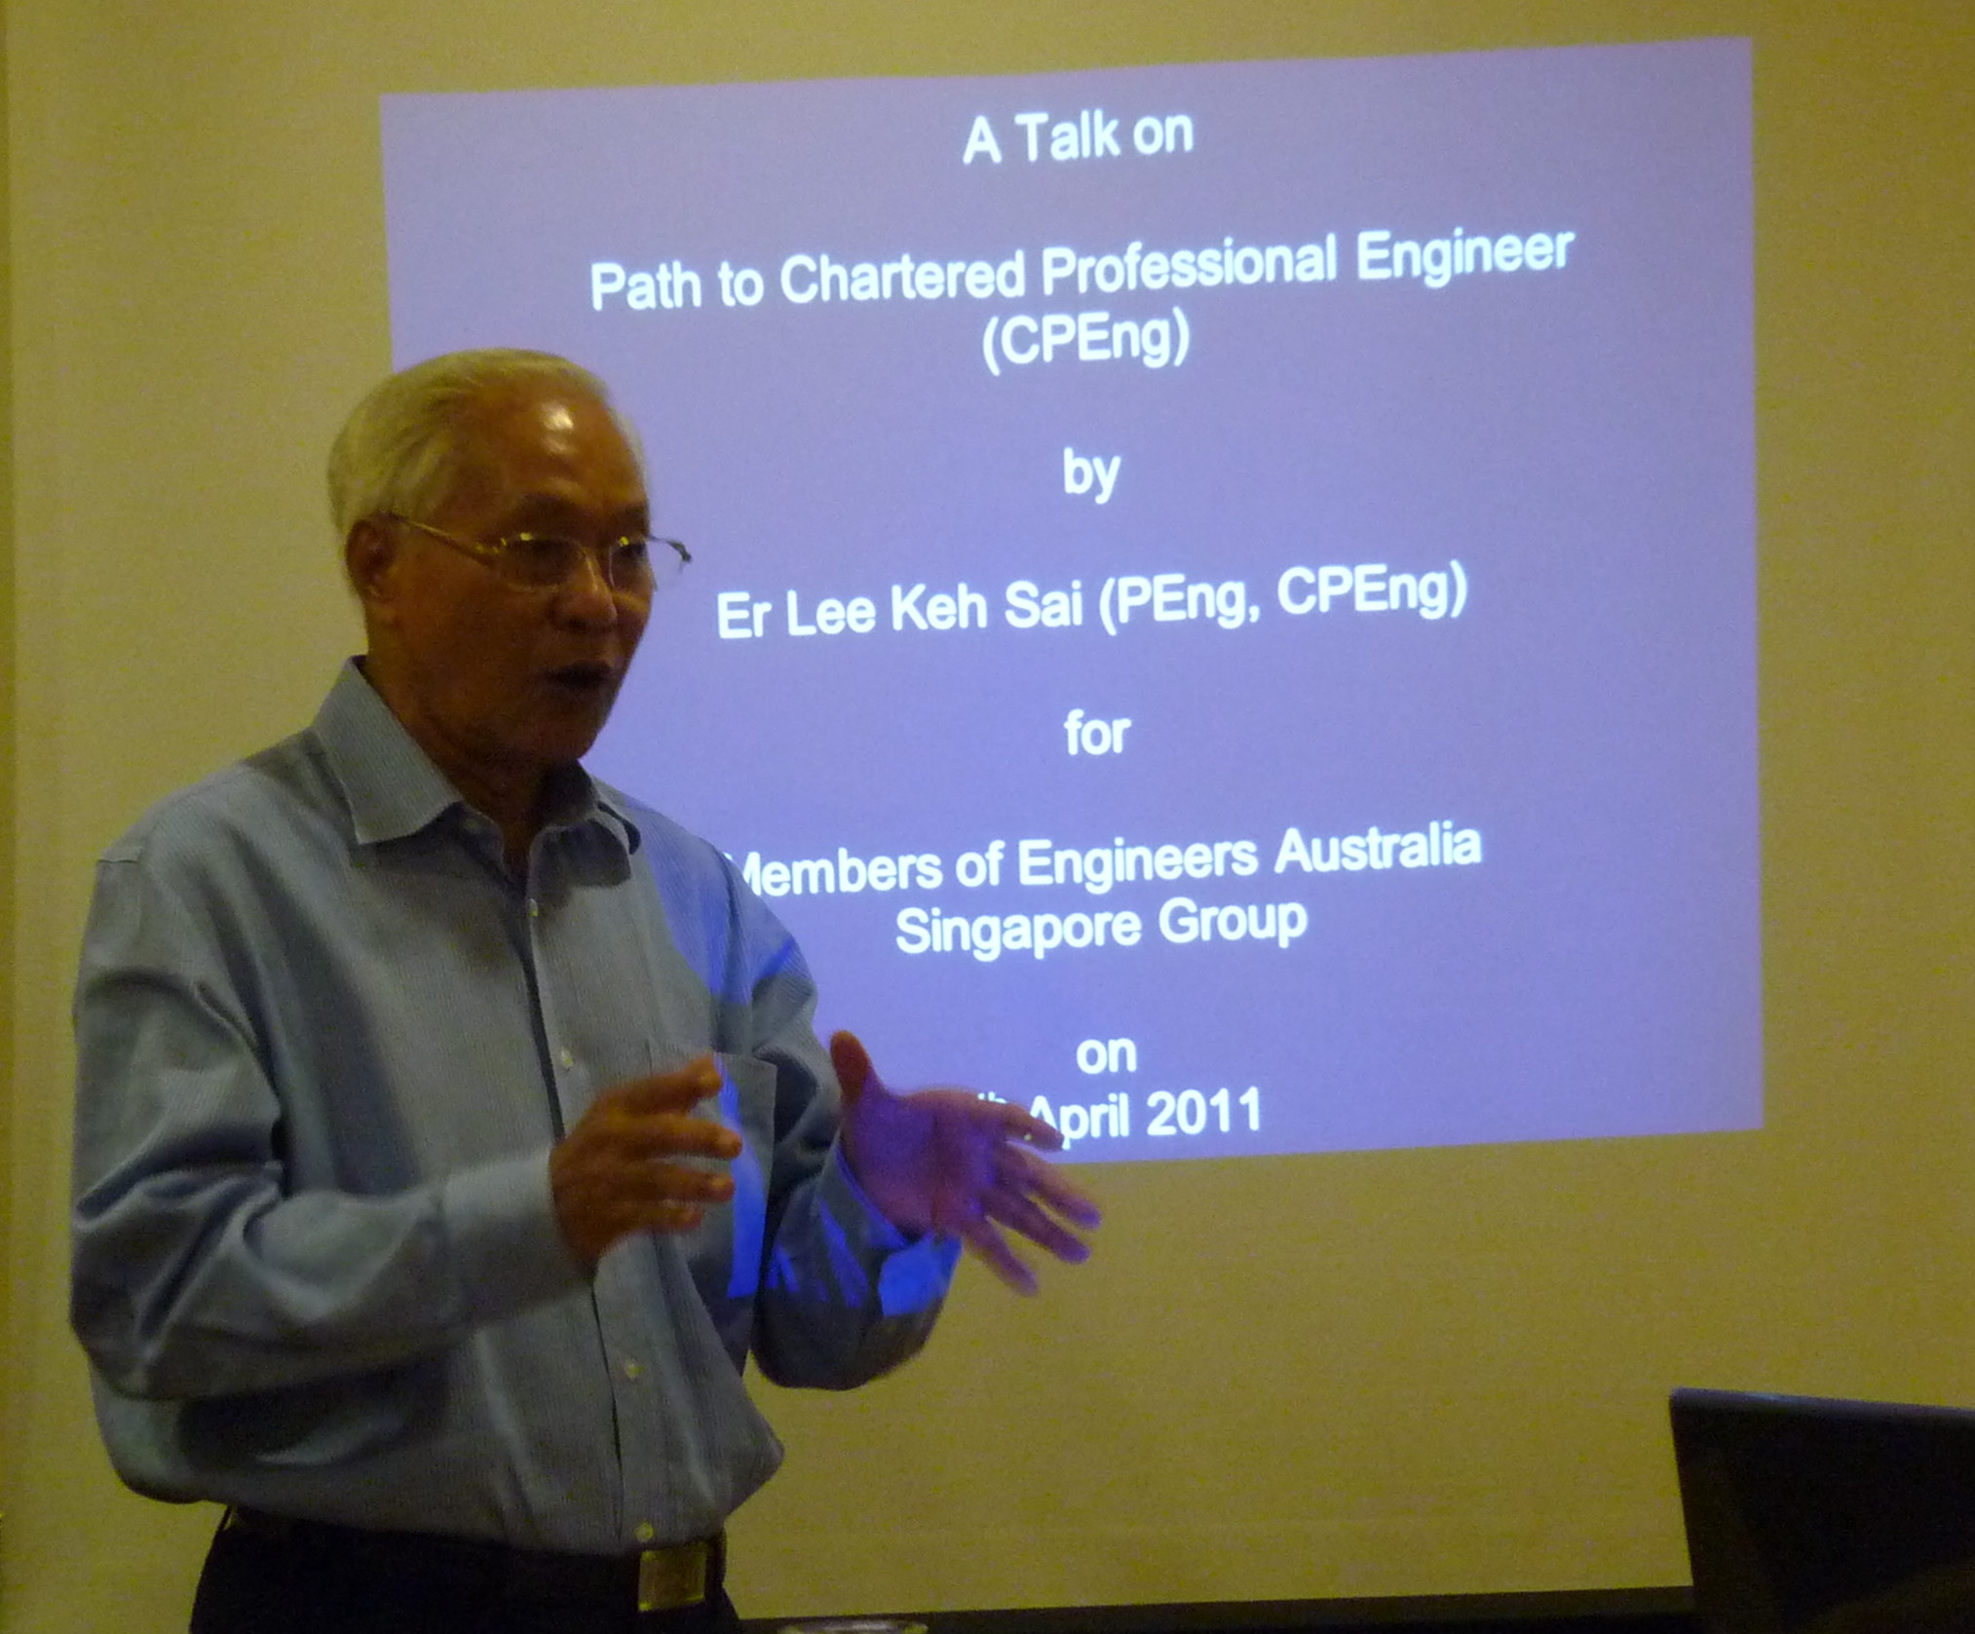
Dr Sam Man Keong (岑文强)
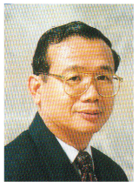

. BE(Civil)(Hons)(MelbU), MSc(Civil)(NUS), MSc(GeotEng)(NTU), EdD(WMSU), GradDipAppStat(RMIT), GDSTT(CIAE), Dip(Civil)(SP), SOE Parts 2 (Civil Design) & 3 (Management), CEI Part 2(Structural).
. CEng, FIET, MICE, MIMMM, MCIHT, CEng, MIEI, CPEng, MIEAust, MIPENZ, MIEPNG, SrMIES, FSPE, PEng(UK), FBEng, CEnv, MCIOB, FCQI, CQP, CMath, MIMA, CSci, FCollT, LFTAM, FSIET(F).
. Initiator and one of the Founder Members of the Singapore Institute of Engineering Technologists (SIET) in 1980.
. Email: sammk1951@gmail.com

Dr Sam is an educationist, teacher, researcher and practitioner for more than 40 years. He has taught in Singapore and other countries including Papua New Guinea and PR China. He is also a life-long learner.

Dr Sam obtained his First Degree in Civil Engineering from the University of Melbourne in Australia. Later, he completed his postgraduate degrees from various local & overseas Universities including the National University of Singapore (NUS) and the Nanyang Technological University (NTU).

Dr Sam has also completed various external examinations by self-study : Cambridge Higher School Certificate, LCCI Business Statistics, RSA Quantitative Methods for Business, The Society of Engineers , UK Part 2 (Civil Design) and Part 3 (Management) and The Council of Engineering Institutions, UK Part 2 (Now : The Engineering Council).

Dr Sam has been very active in many professional bodies. In 1980 he initiated the formation of the Singapore Institute of Engineering Technicians (SIET – later renamed as the Singapore Institute of Engineering Technologists) and served in the Executive Council for almost 25 years.. He was awarded the SIMMS Medal by the Society of Engineers, UK in 1985. Currently he is the local representative of the Association of Building Engineers, UK , and Member, Engineering Advisory Board for the BEng(Mechanical & Manufacturing) Program in Singapore for the University of South Australia. He has been a ‘Professional Interviewer’ for various UK Professional Bodies for registration as ‘Incorporated Engineer (IEng), Chartered Engineer (CEng) and Chartered Builder.

Dr Sam is a Chartered Engineer (UK/Australia/Ireland), a Chartered Builder (UK), a Chartered Environmentalist (UK), a Chartered Quality Professional (UK), a Chartered Mathematician (UK) and also a Chartered Scientist (UK).

